 | - To study AWK programming

Name of Student | RONIT PATANGE | Roll No. | 9145
Sign here to indicate that you have read all relevant material provided /available on Moodle while performing and writing this experiment |  | Sign:

Late Submission Details (if any)
Reason(s) of late submission | Date of practical performance | Date of practical submission

References used
1 | Name and author of reference book(s) with page nos.
2 | Name and roll nos. of the peers whose help you have taken (if any)

Rubrics for assessment of Experiment:
Indicator | Poor | Average | Good
Timeliness  Maintains Experiment deadline (3) | Experiment not done (0) | One or More than One week late (1-2) | Maintains deadline (3)
Completeness and neatness  Complete all parts of Experiment (3) | N/A | < 80% complete (1-2) | 100% complete (3)
Originality  Extent of plagiarism (2) | Copied it from someone else (0) | At least try to implement but could not succeed (1) | Implemented (2)
Knowledge  In depth knowledge of the Experiment (2) | Unable to answer any questions (0) | Unable to answer few questions (1) | Able to answer all questions (2)

Assessment Marks:
Timeliness
Completeness and neatness
Originality
Knowledge
Total

Signature of Teacher with date

1. | Course, Subject & Experiment Details

Course & Branch | T.E. (ECS) | Estimated Time | 02 Hours Per Week
Current Semester | Semester VI | Subject Name | Linux Server Administration
Chapter No. & Unit | 5.1 | Chapter Title | Bash Shell Scripting
Experiment Type | Software Performance | Subject Code | ECL 604

2. | Aim & Objective of Experiment
- To write programs using awk programming
3. | Expected Outcome of Experiment
- To understand awk programming
4. | Brief Description of the experiment

Refer the website: https://zetcode.com/lang/awk/

- Print all words included in the words.txt file that are longer than eight characters.
- Print all words that have three characters from words.txt
- Print all words in the file words.txt along-with the length of each.
- Print all students with scores 90+ from scores.txt
- Print average of all scores from scores.txt
- Print unique names of cities from users.txt
- Print names of all females with the number of characters in the name from users.txt
- Print total no. of users, total no. of males and females from users.txt
- Prints all words that end with e or n from words.txt
- Remove line numbers from source.c file and save the extracted program (without line numbers) in another file modified_source.c
- Print sum of all numbers (line wise) from values.txt
- Do this for extra credits: Make any one game using awk

Note: For each program above include following things in the writeup:

Code, algorithm and screenshot of the output

- 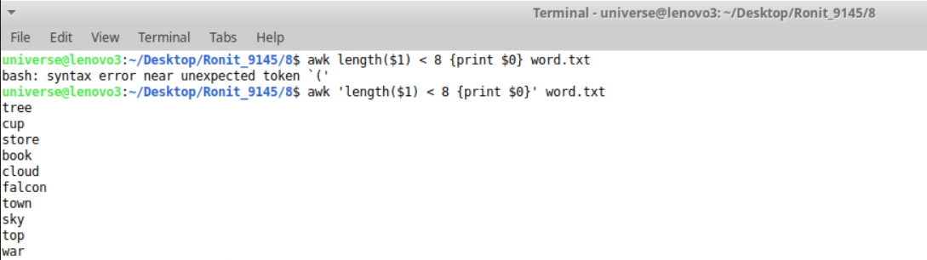

- 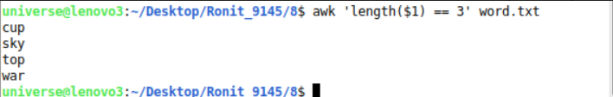

- 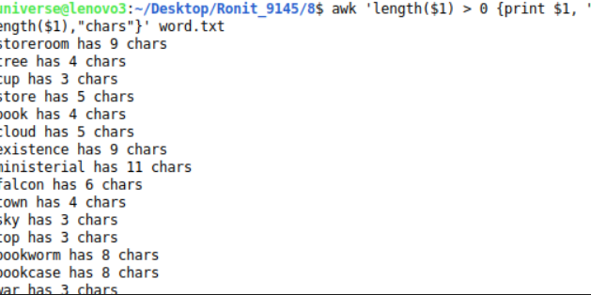

- 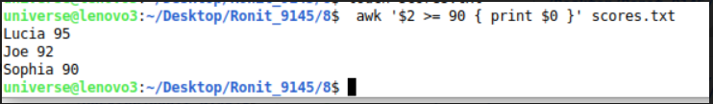

- 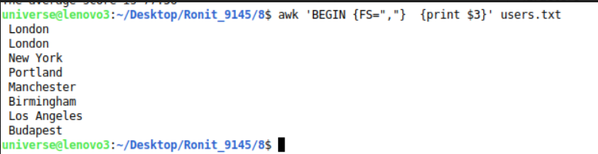

- 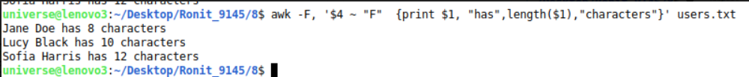

- 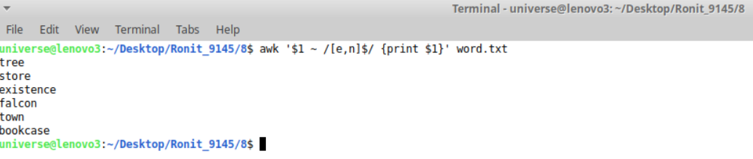

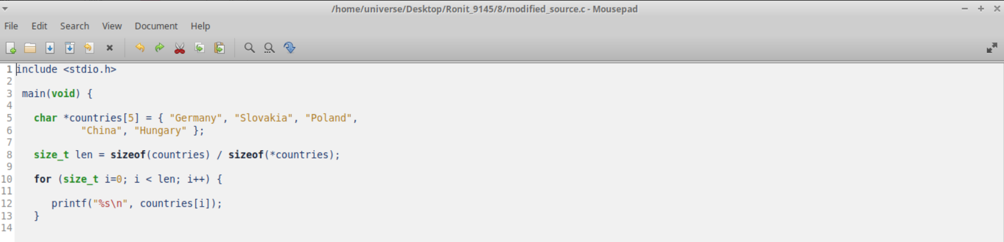

- 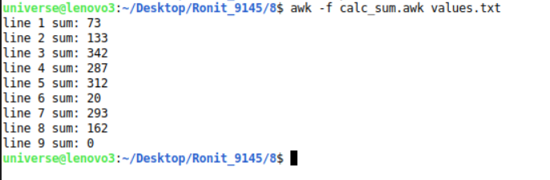

- 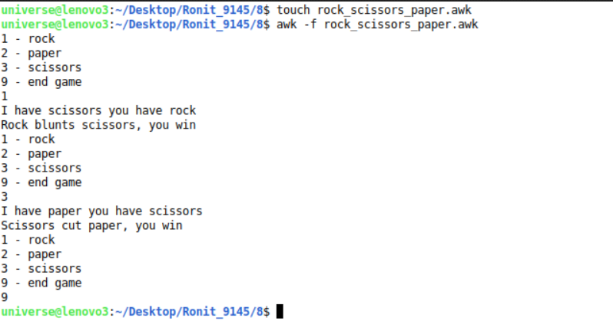

5. | Conclusions & Inferences

Understood and executed awk programs.

6. | Post Lab exercise

- Write a note on “sed programming” with the help of an example code

SED command in UNIX stands for stream editor and it can perform lots of functions on file like searching, find and replace, insertion or deletion. Though most common use of SED command in UNIX is for substitution or for find and replace. By using SED you can edit files even without opening them, which is much quicker way to find and replace something in file, than first opening that file in VI Editor and then changing it. SED is a powerful text stream editor. Can do insertion, deletion, search and replace(substitution).SED command in unix supports regular expression which allows it perform complex pattern matching.

$sed 's/unix/linux/' ronit.txt.
This command replaces the word “unix” with “linux” in the file

